Table 2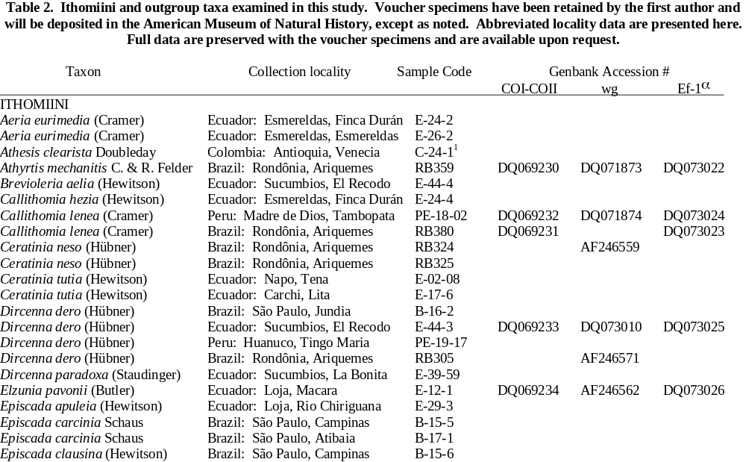. Ithomiini and outgroup taxa examined in this study. Voucher specimens have been retained by the first author and will be deposited in the American Museum of Natural History, except as noted. Abbreviated locality data are presented here. Full data are preserved with the voucher specimens and are available upon request.

Taxon Collection locality Sample Code Genbank Accession #
COI-COII wg Ef-1α
ITHOMIINI
Aeria eurimedia (Cramer) Ecuador: Esmereldas, Finca Durán E-24-2
Aeria eurimedia (Cramer) Ecuador: Esmereldas, Esmereldas E-26-2
Athesis clearista Doubleday Colombia: Antioquia, Venecia C-24-1¹
Athyrtis mechanitis C. & R. Felder Brazil: Rondônia, Ariquemes RB359 DQ069230 DQ071873 DQ073022
Brevioleria aelia (Hewitson) Ecuador: Sucumbios, El Recodo E-44-4
Callithomia hezia (Hewitson) Ecuador: Esmereldas, Finca Durán E-24-4
Callithomia lenea (Cramer) Peru: Madre de Dios, Tambopata PE-18-02 DQ069232 DQ071874 DQ073024
Callithomia lenea (Cramer) Brazil: Rondônia, Ariquemes RB380 DQ069231 DQ073023
Ceratinia neso (Hübner) Brazil: Rondônia, Ariquemes RB324 AF246559
Ceratinia neso (Hübner) Brazil: Rondônia, Ariquemes RB325
Ceratinia tutia (Hewitson) Ecuador: Napo, Tena E-02-08
Ceratinia tutia (Hewitson) Ecuador: Carchi, Lita E-17-6
Dircenna dero (Hübner) Brazil: São Paulo, Jundia B-16-2
Dircenna dero (Hübner) Ecuador: Sucumbios, El Recodo E-44-3 DQ069233 DQ073010 DQ073025
Dircenna dero (Hübner) Peru: Huanuco, Tingo Maria PE-19-17
Dircenna dero (Hübner) Brazil: Rondônia, Ariquemes RB305 AF246571
Dircenna paradoxa (Staudinger) Ecuador: Sucumbios, La Bonita E-39-59
Elzunia pavonii (Butler) Ecuador: Loja, Macara E-12-1 DQ069234 AF246562 DQ073026
Episcada apuleia (Hewitson) Ecuador: Loja, Rio Chiriguana E-29-3
Episcada carcinia Schaus Brazil: São Paulo, Campinas B-15-5
Episcada carcinia Schaus Brazil: São Paulo, Atibaia B-17-1
Episcada clausina (Hewitson) Brazil: São Paulo, Campinas B-15-6
Episcada hymenaea (Prittwitz) Brazil: São Paulo, Cotia B-12-3
Epityches eupompe (Geyer) Brazil: São Paulo, Cotia B-12-2
Forbestra equicola (Cramer) French Guiana: Kaw G-36-2
Forbestra olivencia (Bates) Peru: Madre de Dios, Tambopata PE-18-3
Godyris duillia (Hewitson) Ecuador: Zamora-Loja hwy km 40 E-37-1
Godyris zavaleta (Hewitson) Ecuador: Sucumbios, El Recodo E-44-1 DQ069235 DQ073011 DQ073027
Greta andromica (Hewitson) Ecuador: Sucumbios, La Bonita E-39-29
Greta annette (Guérin Costa Rica: Monte Verde CR-1-5
Greta hermana (Haensch) Ecuador: Sucumbios, La Bonita E-39-46 DQ069236 DQ073012 DQ073028
Greta morgane (Geyer) (captive-reared specimen) 70-9² AY090206 AY090139 AY090172
Greta polissena (Hewitson) Ecuador: Carchi, Lita E-17-9
Greta theudelinda (Hew.) Ecuador: Loja, S. Pedro de Vilcab. E-28-4
Heterosais guilia (Hewitson) Peru: Huanuco, Tingo Maria PE-19-1
Hyalenna sp. Ecuador: Zamora, Q. Chorillos E-30-1
Hyalyris antea (Hewitson) Ecuador: Zamora, Q. Chorillos E-30-4 DQ069237 DQ073013 DQ073029
Hyalyris antea (Salvin) Peru: Cuzco, Q. Chaupimayo PE-10-14 AF246589
Hypoleria sp. Brazil: Rondônia, Ariquemes RB358 AF246576
Hypoleria lavinia (Hewitson) Brazil: São Paulo, Jundiai B-16-8
Hyposcada anchiala (Hewitson) Peru: San Martin, Pte. Serranayacu AW-02-0716³
Hyposcada illinissa (Hewitson) Ecuador: Esmereldas, R. Chuchuvi E-20-1
Hypothyris cantobrica (Hewitson) Brazil: Rondônia, Ariquemes RB360
Hypothyris daphnis d’Almeida Brazil: Rondônia, Ariquemes RB237 AF246591
Ithomia avella Hewitson Ecuador: Sucumbios, El Higueron E-35-5
Ithomia drymo Hübner Brazil: São Paulo, Jundiai B-16-5 DQ069238 DQ073014 DQ073030
Ithomia eleonora Haensch 9117
Ithomia iphianassa Doubleday 8804
Ithomia lagusa Hewitson Ecuador: Zamora, Q. Chorillos E-30-6
Ithomia salapia Hewitson Ecuador: Sucumbios, El Recodo E-44-2
Ithomia terra Hewitson Ecuador: Pichincha, Tandapi E-15-2
Mcclungia cymo (Hübner) Brazil: São Paulo, Campinas B-15-1
Mcclungia cymo (Hübner) Brazil: São Paulo, Campinas B-19-3
Mechanitis polymnia (Linnaeus) Brazil: São Paulo, Campinas B-15-2
Mechanitis polymnia (Linnaeus) Panama: Gamboa P4
Mechanitis polymnia (Linnaeus) Brazil: Rondônia, Ariquemes RB233 AF246560
Megoleria susiana (C & R Felder) Peru: San Martin, La Antena AW-02-0402³
Melinaea menophilus (Hewitson) Brazil: Rondônia, Ariquemes RB288 DQ069240 AF014146 DQ073032
Melinaea isocomma Forbes Ecuador: Sucumbios, La Bonita E-39-52
Methona confusa Butler Peru: San Martin, Tarapoto AW-02-0622
Methona themisto (Hübner) Brazil: São Paulo, M. Guaçu B-20-1
Methona sp. Brazil: Rondônia, Ariquemes RB296 DQ069239 DQ073015 DQ073031
Napeogenes apulia (Hewitson) Ecuador: Sucumbios, La Bonita E-39-58
Napeogenes cranto C & R Felder 8313
Napeogenes duessa (Hewitson) Ecuador: Napo, Rio Tiputini E-46-2
Napeogenes larilla (Hewitson) Ecuador: Sucumbios, La Bonita E-39-47 DQ069241 DQ073016 DQ073033
Napeogenes pharo (C & R Felder) Brazil: Rondônia, Ariquemes RB235 AF246601
Napeogenes sylphis Ecuador: Napo, Rio Tiputini E-46-1
(Guérin-Méneville)
Oleria aquata (Weymer) Brazil: Rondônia, Ariquemes RB321 AF246558
Oleria onega (Hewitson) Peru: S. Martin, Pongo-Barranquita AW-02-0515³
Oleria santineza (Haensch) Ecuador: Sucumbíos, Río Sucio W-3-2†
Ollantaya aegineta (Hewitson) Ecuador: Zamora, Loja-Zamora rd. E-32-1
Olyras insignis Salvin Ecuador: Esmereldas, Finca Durán E-24-1
Pagyris cymothoe (Hewitson) Ecuador: Pichincha, San Antonio E-16-2 DQ073035
Pagyris cymothoe (Hewitson) Ecuador: Loja, S. Pedro de Vilcab. E-28-3
Pagyris ulla (Hewitson) Ecuador: Sucum., La Bonita-Tulcan E-43-18
Paititia neglecta Lamas Peru: San Martin AW-02-1244³ DQ073038 DQ073017 DQ073034
Patricia dercyllidas (Hewitson) Ecuador: Sucumbios, El Higueron E-35-7
Placidina euryanassa Brazil: São Paulo, Jundiai B-16-1
(C & R Felder)
Placidina euryanassa Brazil: São Paulo, Atibaia B-17-2
(C & R Felder)
Pseudoscada erruca (Hewitson) Brazil: S. Paulo, Campos do Jordåo B-13-3
Pseudoscada timna (Hewitson) Brazil: São Paulo, M. Guaçu B-20-3
Pseudoscada timna (Hewitson) Ecuador: Carchi, Lita E-17-4
Pteronymia aletta (Hewitson) Ecuador: Esmereldas, Esmereldas E-26-1
Pteronymia hara (Hewitson) Ecuador: Sucumbios, La Bonita E-39-43
Pteronymia oneida (Hewitson) Ecuador: Sucum., La Bonita-Tulcan E-43-1
Pteronymia teresita (Hewitson) Ecuador: Loja, R. Chiriguana E-29-1
Pteronymia ticida (Hewitson) Ecuador: Sucumbios, La Bonita E-39-34
Pteronymia tucuna (Bates) Peru: Cuzco, Q. Chaupimayo PE-10-12 AF246606
Pteronymia veia (Hewitson) Ecuador: Sucum., La Bonita-Tulcan E-43-16 DQ069042 DQ073018 DQ069242
Sais rosalia (Cramer) Peru: Madre de Dios, Tambopata PE-18-5
Scada reckia (Hübner) Peru: Cuzco, Q. Chaupimayo PE-10-15
Thyridia psidii (Linnaeus) Peru: Cuzco, Q. Chaupimayo PE-10-11
Thyridia psidii (Linnaeus) Brazil: Rondônia, Ariquemes RB314 AF014147
Tithorea harmonia (Cramer) Peru: Huanuco, Tingo Maria PE-19-19 DQ069043 DQ073019
Tithorea harmonia (Cramer) Venezuela: Barran., Delta Amacuro V20 AF246561
Veladyris pardalis (Salvin) Ecuador: Sucum., La Bonita–Tulcan E-45-1
Velamysta phengites Fox Ecuador: Sucumbios, La Bonita E-39-32
Velamysta pupilla (Hewitson) Ecuador: Sucum., La Bonita–Tulcan E-43-3⁴ DQ071864 DQ073020 DQ073021

TELLERVINI
Tellervo zoilus (Fabricius) Australia: Queensland, Kirrana S. F. QL1 AF246563

DANAINI
Amauris ellioti Butler Tanzania: Mbeya Range (Wahlberg)² AY218234 AY218272 AY218253
Danaus erippus (Cramer) Argentina: Buenos Aires DE-1 AY569158
Euploea camaralzeman Butler (captive-reared specimen)) 70-8² AY090205 AY090138 AY090171
Lycorea cleobaea (Godart) Brazil: Rondônia, Ariquemes RB241 AF246567

¹ voucher retained at UNICAMP, Campinas, Brazil.
² voucher retained by N. Wahlberg (sequences from GenBank)
³ voucher retained at the Natural History Museum, London
⁴ voucher retained by K. R. Willmott

